**Project Design Phase-II**

**Technology Stack (Architecture & Stack)**

|  |  |
| --- | --- |
| Date | 27 June 2025 |
| Team ID | LTVIP2025TMID44293 |
| Project Name | Traffic Intelligence : Advanced Traffic Volume Estimation with Machine Learning |
| Maximum Marks | 4 Marks |

**Technical Architecture:**

Guidelines:

Include all the processes (As an application logic / Technology Block)

Provide infrastructural demarcation (Local / Cloud)

Indicate external interfaces (third party API’s etc.)

Indicate Data Storage components / services

Indicate interface to machine learning models (if applicable)

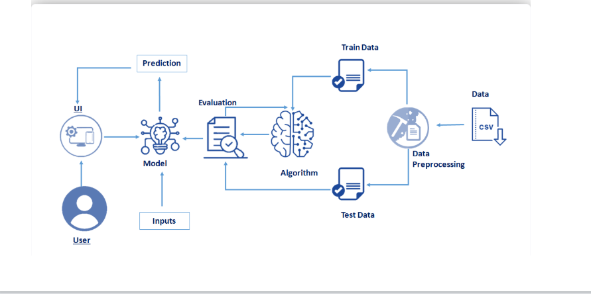

**Table-1 : Components & Technologies:**

|  |  |  |
| --- | --- | --- |
| **S.No** | **Component** | **Technology / Tool** |
|  | Frontend | HTML , CSS |
|  | Backend | Python (Flask)  TensorFlow |
|  | Database | SQLite/MYSQL  Firebase (optional for authentication) |
|  | Storage | Local Storage / Cloud |
|  | Authentication | E-mail / OTP Verification |
|  | Deployment | Render / Vercel / AWS(for hosting web app) |

**Application Characteristics:**

1. Real-time Processing
2. Data-driven Insights
3. Scalable Architecture
4. Cross-Platform Compatability
5. Customizable & Configurable
6. Intelligent Decision Support
7. Low Maintenance & Cost-effective
8. Secure & Privacy-Compliant
9. Fault Tolerance & Redundancy
10. User-friendly Interfacace